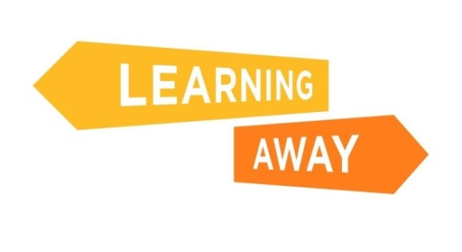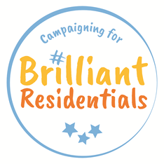
LA99

Learning Away Consortium
Manifesto

Our Vision

The Consortium’s vision is to improve outcomes for children and young people by ensuring every child has access to and benefits from high quality residential learning experiences.

Brilliant Residentials

As a result of our initial ‘action research’ we have a clear picture of what we mean by high-quality residential learning, and have coined the phrase ‘Brilliant Residentials’ to describe these experiences.

Brilliant Residentials are school trips with at least one overnight stay, which are:

- fully integrated with the school curriculum and ethos;
- designed and led by teachers and, where appropriate, students;
- inclusive and affordable for all students;
- deliberately and collaboratively planned to meet students’ specific learning needs, and to embed and reinforce learning back in school;
- part of a progressive programme of experiences;
- designed to include a wide range of new and memorable experiences;
- designed to allow space for students to develop collaborative relationships with both peers and staff;
- evaluated rigorously;
- supported by senior leadership and school governors.

The Consortium has identified that is particularly important to highlight that Brilliant Residentials do not need to be expensive, and can be delivered through a wide variety of opportunities (e.g. arts and cultural experiences, heritage, fieldwork, school grounds, outdoor adventurous activities) as part of a progressive programme of experiences.

The Learning Away Consortium

Consortium members are united in their commitment to ensuring that every child and young person has access to high-quality ‘Brilliant Residential’ learning experiences.
The purpose of the Consortium is to:
- To promote and champion residential learning to enable all children and young people in educational and youth settings across the UK to benefit from these experiences.
- To tackle the challenges highlighted in recent evidence that suggests children and young people from disadvantaged backgrounds are less likely to take part in residential learning experiences.
- To provide practical support to schools and providers to enable more effective and high quality residential experiences.
- To be the leading voice for residential learning across the UK.
- To ensure a lasting legacy for the PHF Learning Away programme.

Aims and objectives

- The aims of the Consortium are:
  - To continue to make the case for and build the evidence base for Brilliant Residentials;
  - To share learning of what we know works, including campaigns to take the initial ‘action research’ and new research and studies to schools, providers and the wider public policy debate;
  - To continue to test and develop what makes a ‘Brilliant Residential’ in new contexts (beyond the models and context tested in the original Learning Away ‘action research’);
  - To promote the CPD materials and free resources to support schools to run Brilliant Residentials;
  - To create more resources to support providers to run Brilliant Residentials (including the development of new, cheaper or easier to access, models of provision);
  - To measure the success of these aims against a series of outputs, and the established baseline and monitoring framework;
  - To expand our reach and impact beyond England across the rest of the UK;
  - To support the potential for the longer-term sustainability of the Learning Away programme, as new funding and other income streams are developed by the Consortium;
  - To support the development of an effective, well-managed and sustainable Consortium that represents the wide variety of residential experiences available.

- The Consortium’s agreed objectives for the next two years (April 2018 to April 2020) are:

- To run a communications and advocacy campaign calling for Brilliant Residentials for All, focusing specifically on the impacts for disadvantaged pupils, to enable schools to make the case for investing in affordable and inclusive residential programmes for all pupils;
- To deliver and support partners to deliver a programme of face to face and online CPD for school staff and senior leaders aimed at changing practice;
- To publish and disseminate new research, including a comparative case study investigating the link between residentials and SATs attainment for Year 6 pupils from schools;
- To work with our research working group to develop and commission new research to understand the impacts of residentials on disadvantaged pupils compared with their more affluent peers;
- To promote and provide free access to a new evaluation toolkit to help schools measure and improve the impact of their residentials and justify future investment in inclusive residential programmes;
- To promote and provide free access to resources and case studies to help schools experiment with new residential models and overcome the funding challenges;
- To produce a second independently evaluated report on ‘The State of School Residentials’ examining access to residentials for disadvantaged students in 2019, monitoring changes in the quantity and quality of provision compared with our 2017 baseline data;
- To develop a central funding pot to enable providers to fund pilot residentials that have a specific focus on inclusive practice.

January 2018

