Mountain Leader training course notes

Introduction
The Mountain Leader award was established to promote the safe enjoyment of the hills and mountains. The scheme provides training and assessment in the technical and group management skills required by those who wish to lead groups in the mountains, hills and moorlands of the United Kingdom and Ireland, other than in winter conditions. The Mountain Leader scheme offers the opportunity to gain technical competence in leading walkers in the hills and mountains. It does not provide a rock climbing qualification, nor does it cover the skills required for the planned use of a rope.

The Mountain Leader training course aims to develop the technical skills, judgements and areas of knowledge deemed necessary to ensure an individual is safe to work within the scope of the award.

This is a 6 day course (minimum of 60 hours)

www.mountain-training.org/walking/skills-and-awards/mountain-leader

Prerequisites for the Mountain Leader training course
Before you book onto a Mountain Leader training course;
- You must be registered on the scheme
- You must have recorded a minimum of 20 Quality Mountain Days which can have taken place at any point (pre or post registration).

Please ensure you have entered your minimum prerequisites in your digital logbook (DLOG) at the time of confirming your place on the training course.

Mountain Leader training course content

The course will cover the Mountain Leader syllabus which includes the following areas:

- Group management and the responsibilities of the group leader
- Navigation
- Access and the environment
- Hazards (including steep ground and rivers) and emergency procedures
- Equipment
- Expedition skills
- Weather
- Background knowledge

Detailed information on each of the above topics can be found in the Mountain Leader Handbook, and the onus is on you to be competent in all of them by the time you come to assessment.

Potential outcomes
Following training, a course report will be completed. The results you can achieve are:

Completed: You have attended and completed the training course and met the prerequisite requirements.

Not yet completed: If for any reason you do not complete the required hours for a course you will receive this result. In all cases an action plan will be discussed and created for you. Providers have up to 21 days to submit a course report, which allows for you to submit further information if necessary, for example if you have not fully met the prerequisite requirements.

Candidates are reminded that attendance on a training course must not in any way be considered a qualification in its own right. This is only achieved by passing the Mountain Leader assessment.

Insurance
Mountain Training recommends that you consider personal accident and cancellation insurance. If you already have insurance cover, check that it covers you for the activity you are undertaking.

Useful links
Mountain Leader candidate handbook
Hillwalking by Steve Long: the official handbook for Mountain Training’s walking schemes
Mountain Training’s YouTube channel
Mountain Training’s Reasonable Adjustment policy

Mountain Training Association
British Mountaineering Council

Pendarren House Outdoor Education Centre
Pendarren House is located on the side of Sugarloaf Mountain in the Brecon Beacons National Park and is ideally situated with a variety of venues close by. The Centre is well resourced with a variety of audio visual equipment, minibuses, drying room and WiFi. Whilst at Pendarren accommodation will be in single or twin rooms in the Firs bungalow. The expedition and managing groups on steep ground will take place in Snowdonia where we will be based from tents. All transport during the course is included.
Travel
If arriving by train or bus we can pick up from the stations in Abergavenny. At the end of the course the minibus will be travelling back to Pendarren and can drop candidates at Abergavenny station, or you can remain in Snowdonia. If you wish to stay the night before the course please contact Pendarren; this will be self catering and there is no charge

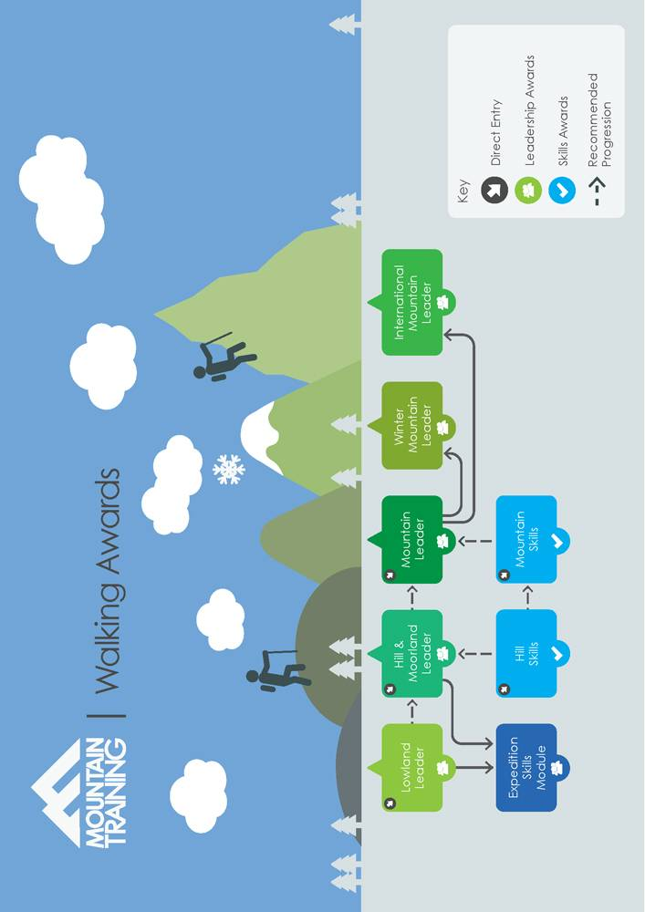
Course programme

Provider: Pendarren House OEC
Course start date and time: 20th October 201; 9.00
Meeting location: Pendarren House OEC, Llangenny, Crickhowell. Powys NP8 1HE

Day 1
- Meet at Pendarren House 9.00
- Course introductions and Mountain Training ethos
  - Qualification pathways and scope of the scheme
  - Course programme
  - Outcomes
  - Discussion of prerequisites, qualifications and the Expedition Skills Module
  - About Mountain Training, the Mountain Training Association and Mountaineering Councils
- Introduction to:
  - Mountain navigation
  - Group Management
  - Access and conservation
- Feedback

Evening
- Weather
- Background information

Day 2
- Introduction and development of:
  - Weather interpretation
  - Navigation, walking and route finding in the mountains
  - Access and conservation
- Feedback

Evening
- Responsibilities of a Mountain Leader
- Introduction to:
  - Duty of care and responsibilities
  - Principles of safety management

Day 3
- Introduction to and development of:
  - Simple rope techniques
  - Mountain safety and emergency procedures
  - Improvised rescue
  - Basic searches
  - Mountain rescue
- Feedback

Evening
To Snowdonia

Day 4
- Introduction to and development of:
  - Navigation
  - Group management
  - Leadership strategies
  - Hazards of steep ground (with and without a rope)
  - Access and conservation
- Feedback

Evening
- Expedition planning
- Introduction to and development of:
  - Route planning
  - Expedition equipment and packing
  - Food and cooking

Day 5
- Mountain Expedition and overnight wild camp
- Weather interpretation
- Introduction to and development of:
  - Navigation
  - Group management
  - Access and conservation
  - Camp craft and associated equipment
- Feedback

Evening
- Poor visibility/ night navigation

Day 6
- Mountain Expedition
- Introduction to and development of:
  - Navigation
  - Group management
  - Access and conservation
  - Camp craft and associated equipment
  - River crossing
- Feedback
- Discussion of Digital Logbook (DLOG) and personal action plans for consolidation period and assessment

The programme is subject to change to make best use of the weather and venues chosen for the course.

Equipment
Please ensure you have the following equipment (this list is not exhaustive):

- Appropriate mountain walking clothing
- Waterproof jacket*
- Waterproof trousers*
- Spare clothes (warm layer)
- Rucksack 30-40L and liner
- Walking boots*
- Warm hat and gloves or sun hat and sun screen
- Vacuum flask / water bottle
- Group first aid kit* and personal medication
- Compass - recommend a Silva Type 4*
- Relevant maps (1:25 000* and 1:50 000) for the area
- Group shelter*
- 1 x 30m hillwalking rope*
- Climbing helmet*
- Head torch + spare batteries
- GPS/Altimeter - please bring along if you have these
- Expedition rucksack 50-60l
- Mountain tent*
- Sleeping bag*
- Sleeping mat*
- Stove/fuel*
- Bowl/cutlery*
- Toiletries, Trowel*
- Notebook and pen

Candidates may have all the required equipment but some can be borrowed at no extra cost if required. The items marked * are available to borrow for the course (although they may be more ‘robust’ and heavy than what you prefer!).

Pendarren House OEC
Llangenny
Crickhowell
Powys
NP8 1HE

01873 810694
a.lewington@pendarren.org
www.pendarren.org

