**The Firs Bungalow**

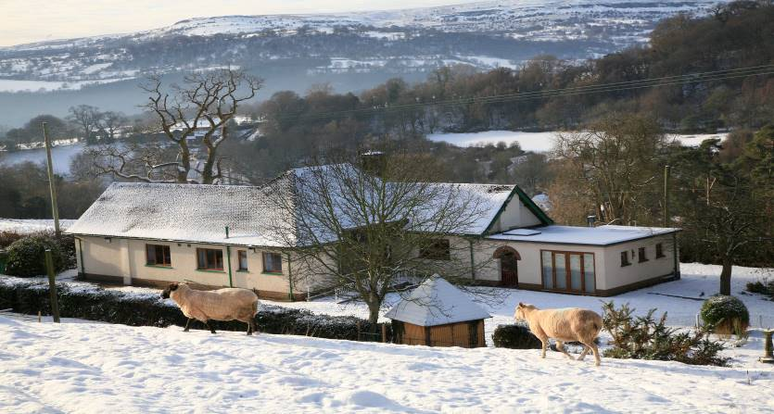

**How to book accommodation and / or activities:**

To book, return a completed booking formand a holding fee / damage waiver payment of £150.00. If paid by cheque, this will not be banked and will be returned to you after your stay subject to the accommodation being left in a clean and tidy condition.

The balance of the payment for your booking is due **at least** six weeks before the first day of your booking. Reminders or invoices will not be issued unless specifically requested.

If you book less than six weeks before the first date of your visit, a holding fee of £150.00 plus the full cost of accommodation and activities (if available) will be required. The deposit will be returned subject to the accommodation being left in a clean and tidy condition.

**PLEASE NOTE - ALL PRICES ARE INCLUSIVE OF VAT**

All payments should be made payable to LBH - Pendarren House OEC and paid via BACS using the details below.

**Lloyd’s plc: Account: 17821962 Sort code 30-99-50**

The postal address for the centre is:

**Pendarren House OEC, Llangenny, Crickhowell, Powys NP8 1HE**

If you should have any queries regarding the hiring of The Firs, please do not hesitate to contact Pendarren House by telephone on (01873) 810694 or by email at: [office@pendarren.org](mailto:office@pendarren.org)

**The Firs at Pendarren House Outdoor Education Centre**

**Booking Form**

|  |  |  |  |  |  |  |
| --- | --- | --- | --- | --- | --- | --- |
| **Date of arrival:** |  | | | **Date of departure:** |  | |
|  | | | | | | |
| **Accommodation Prices:** | | | |  | | |
| **Groups of up to 8** | | | | **Minimum booking of 2 nights** | | |
| March 2024 to October 2024 | | | | £280.00 for the property per night | | |
| November 2024 to February 2025 | | | | £250.00 for the property per night | | |
| March 2025 to October 2025 | | | | £300.00 for the property per night | | |
| November 2025 to February 2026 | | | | £280.00 for the property per night | | |
| **Groups of 9 to 16** | | | |  | | |
| March 2024 to October 2024 | | | | £400.00 for the property per night | | |
| November 2024 to February 2025 | | | | £320.00 for the property per night | | |
| March 2025 to October 2025 | | | | £440.00 for the property per night | | |
| November 2025 to February 2026 | | | | £360.00 for the property per night | | |
|  | | | | | | |
| A holding fee / damage waiver payment of **£150.00** is due at the time of booking.  This will be refunded after your visit if the property is left in a clean and tidy condition. | | | | | | |
|  | | | | | | |
| **The final payment is due at least 6 weeks before the first date requested above** | | | | | | |
| **Accommodation** | | | |  | | |
| Number of nights x cost per night (from table above) | | | | = | | |
| **Activities** | | | |  | | |
| Amount due as calculated in request box below | | | | = | | |
| **TOTAL AMOUNT DUE** | | | | = | | |
|  | | | | | | |
| **Details of person / group making booking** | | | | | | |
| **Main contact name** | | |  | | | |
| **Main contact postal address** | | |  | | | |
|  | | |  | | | |
|  | | |  | | | |
|  | | |  | | | |
| **Main contact email address** | | |  | | | |
| **Main contact telephone number** | | |  | | | |
|  | | | | | | |
| **Size of group** | | | | | | |
| Number of adults | | Number of children | | Number of infants | |  |
|  | |  | |  | |  |

**Details for all persons using The Firs:**

|  |  |  |  |  |  |
| --- | --- | --- | --- | --- | --- |
| **Name:** | | | **Address** | | **Date of birth** |
| *All of the details below are required for insurance purposes only and can be supplied at a later date if not known at time of booking*  *See privacy statement in terms and conditions regarding use of data* | | | | | |
| **1** |  | |  | |  |
| **2** |  | |  | |  |
| **3** |  | |  | |  |
| **4** |  | |  | |  |
| **5** |  | |  | |  |
| **6** |  | |  | |  |
| **7** |  | |  | |  |
| **8** |  | |  | |  |
| **9** |  | |  | |  |
| **10** |  | |  | |  |
| **11** |  | |  | |  |
| **12** |  | |  | |  |
| **13** |  | |  | |  |
| **14** |  | |  | |  |
| **15** |  | |  | |  |
| **16** |  | |  | |  |
| **ACTIVITIES If required, this section must be completed at time of booking.**  ***Contact Pendarren House for activity options and charges*** | | | | | |
| **Date required** | | **Activity / Activities**  **(1x full day or 2x half day)** | | **Number of participants** | **Cost** |
|  | |  | |  |  |
|  | |  | |  |  |
|  | |  | |  |  |
|  | |  | |  |  |
|  | |  | |  |  |
|  | |  | |  |  |
|  | |  | |  |  |
|  | |  | |  |  |
| **Total cost (please carry forward to payment box on main booking form)** | | | | | **£** |

|  |  |
| --- | --- |
| I apply to hire The Firs on behalf of the above organisation / group. I have read and accept the conditions of hire as laid out in the *Terms and Conditions of Booking*. I agree to make payment of the full amount due at least six weeks prior to the booking dates and to pay a £150.00 holding fee / damage waiver at the time of booking which will be refunded if the property is left in a clean and tidy condition. | |
| **Signed:** | **Date:** |

**THE FIRS - TERMS AND CONDITIONS OF BOOKING**

1. **Bookings**.  Your booking will not be confirmed until a completed booking form and holding fee / damage waiver payment has been received. Please note, maximum group size is 16 persons.
2. **Deposit**.  A holding fee / damage waiver payment of £150.00 is required as a deposit.  Should the booking be less than six weeks away, the total balance plus the £150.00 should be paid.  At the end of your stay, if the accommodation has been left in a clean and tidy condition, the £150.00 will be returned.
3. **Balance of the fee**.  The accommodation and activity costs (where booked) should be paid **at least** six weeks before the first day booked.  No invoices will be issued unless requested. In the event that the balance is not received by the due date, Pendarren reserves the right to cancel and re-let The Firs.
4. **Cancellations by clients**.  Cancellations must be made in writing or by email to office@pendarren.org and will be acknowledged.  Cancellations received more than 42 days before the first day of the booking will result in loss of deposit only.  Cancellations received between 41 and 14 days before the first day booked will be subject to a charge of 50 percent of the full cost.  Cancellations less than 14 days before the first day booked will subject to a charge of 100 percent of the full cost.
5. **Cancellation by Pendarren**.  Whilst every effort is made to ensure that booked activities can run as planned Pendarren reserves the right to cancel bookings if conditions are unsuitable.  Full refunds will be paid if Pendarren has to cancel your booking.
6. **Condition of, and damage to, accommodation and resources**.  The refundable deposit of £150.00 per booking is made to ensure that the accommodation is left in a clean and tidy condition.  A charge will be made for cleaning exceeding that expected following reasonable use. Similarly, a charge will be made for repair or replacement as appropriate following wilful damage or avoidable loss of equipment (allowances will be made for reasonable wear and tear).  Any maintenance issues must be reported to Pendarren House.
7. **Insurance**.  Pendarren asks all clients to provide basic personal information to comply with the requirements of our Public Liability insurers.  We reserve the right to refuse a booking if this information is not supplied or if we believe it to be inaccurate.  We recommend that you take out personal insurance to cover all other contingencies.
8. **Arrival.** Please take note of the arrangements for your visit.  If you have booked The Firs, it will be ready for you at 3.00 pm on your day of arrival.  Please let us know what time you will arrive and, if possible, give a phone number so that you can be contacted during your journey.
9. **Departure**.  The Firs should be vacated by 10.00 am on your day of departure.  Later departure may be arranged for a fee - please contact Pendarren.  Accommodation should be left in a clean and tidy condition.  For self catering accommodation this includes cleaning and storing all kitchen equipment and utensils, removing all rubbish to the bins provided and stripping bed linen.
10. **Safeguarding.** All groups making bookings when the centre has children and vulnerable adults on site (mainly weekdays in school term times) will be requested to provide in date DBS certificates for all adults accompanying their group. When the centre in not otherwise occupied this will not be a requirement. Please contact the centre directly if you have any questions regarding your group and safeguarding compliance.

1. **Health and Safety**.  Procedures and guidelines laid down by Pendarren staff should be followed. Familiarise yourselves on arrival with the emergency evacuation procedures. On-site activities at Pendarren are for use with a Pendarren instructor only.
2. **Pets.**  Please contact Pendarren House.
3. **Smoking.**  Haringey Council property, which includes The Firs bungalow, is subject to their NO SMOKING policy.
4. **Activities.** Activities are offered as an optional extra for visitors to the Firs. They are subject to availability and must be booked at the time of booking the accommodation. The cost includes the instructor and activity equipment. The number of participants an instructor can work with depends on the activity.  If you wish to increase the number of participants after booking, you will need to contact Pendarren to check whether instructors are available. Completed consent forms are required from all participants before taking part in an activity. Children under the age of 7 may not be able to participate as suitable equipment may not be available. Sessions run from 9.00 am to 5.00 pm. Pendarren is not responsible for any activities offered by third parties that clients may wish to undertake.

14. **Changes to the programme**.  Activities may need to be changed because of inclement weather, availability of staff or for other reasons.  Alternative activities will be offered.  In the event that a participant is unwilling to co-operate or comply with Centre operational procedures, he or she will be withdrawn or the activity abandoned.  The Pendarren Course Director’s decision is paramount.

**Privacy Statement**

Pendarren House Outdoor Activity Centre needs to collect information about the adults who use the centre to protect their health and wellbeing while at the centre.

Haringey Council owns and maintains the Pendarren Centre; the Council is the data controller for the personal information that we hold about the adults who use the centre.

The Data Protection Act 2018 basis for processing the information is that the processing is necessary for the purposes of legitimate interests pursued by the controller. The legitimate interest is that we need the information contained in the forms to protect the health and wellbeing of the adults who use our service. We will hold the information securely and will not use it for any other purpose. We will not share this information with anyone else except in the event of a complaint or legal claim. We will retain the information for 6 years following the last contact as required by our insurers in case of any incidents, complaints, or legal action.

Haringey Council’s Record of Processing Activities sets out full details of why and how we use personal information. You have a right to access the information that we hold and have inaccurate information corrected. Please see the information on the [Data Protection](http://www.haringey.gov.uk/contact/information-requests/data-protection) section of the Haringey Council website for details of our processing activities, your legal rights relating to how we use your personal data and how to exercise those rights.